Multi byte addition

Note : program running and giving the result but moving to infinite loop just check it once if possible.

Program

; Multi Byte addition

CLC

MOV SI,2000H

MOV DI,3000H

MOV CL,[1050]

L1:MOV AL,[SI]

ADC AL,[DI]

MOV [SI],AL

INC SI

INC DI

DEC CL

JNZ L1

INT 03

Data for input

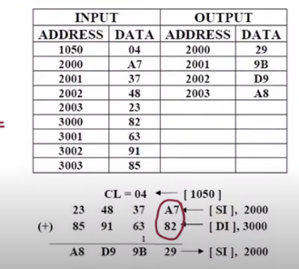

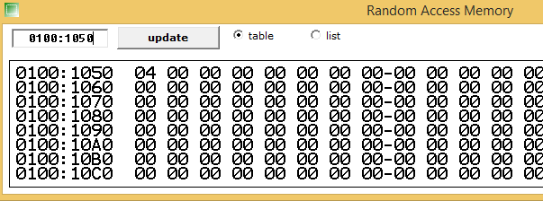

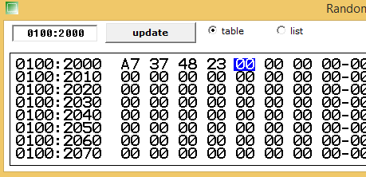

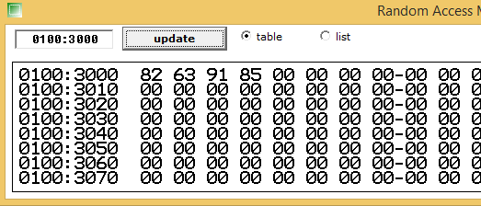

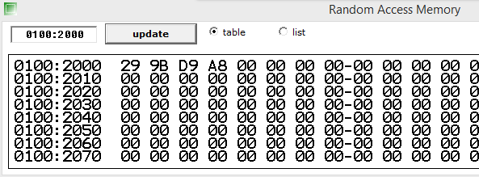

Program: Greatest for 3 numbers AND Taking input from the keyboard

.MODEL SMALL

.DATA

MSG1 DB 10,13,"ENTER 1ST NUM:$"

MSG2 DB 10,13,"ENTER 2ND NUM:$"

MSG3 DB 10,13,"ENTER 3RD NUM:$"

MSG4 DB 10,13,"LARGEST NUM:$"

NUM1 DB ?

NUM2 DB ?

NUM3 DB ?

.CODE

MAIN PROC

MOV AX,@DATA

MOV DS,AX

LEA DX,MSG1

MOV AH,9

INT 21H

MOV AH,1

INT 21H

MOV NUM2,AL

LEA DX,MSG2

MOV AH,9

INT 21H

MOV AH,1

INT 21H

MOV NUM1,AL

LEA DX,MSG3

MOV AH,9

INT 21H

MOV AH,1

INT 21H

MOV NUM3,AL

LEA DX,MSG4

MOV AH,9

INT 21H

MOV BL,NUM1

CMP BL,NUM2

JNG NUMBER2 ;JUMP NOT GREAT BL

CMP BL,NUM3

JNG NUMBER3

MOV DL,NUM1

JMP DISPLAY

NUMBER2:

MOV BL,NUM2

CMP BL,NUM3

JNG NUMBER3

MOV DL,NUM1

JMP DISPLAY

NUMBER3:

MOV DL,NUM3

DISPLAY:

MOV AH,2

INT 21H

Output: 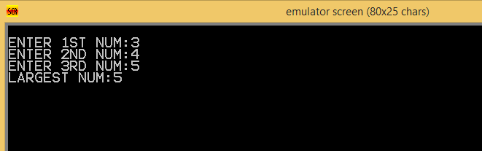

Searching an element in the Array

; FINDING AN ELEMENT IN THE GIVEN ARRAY

MOV SI,1100H

MOV DI,1200H

MOV DL,[DI]

MOV BL,01H

MOV AL,[SI]

AGAIN:

CMP AL,DL ; CMP BOTH ARRAY ELEMENTS

JZ AVAIL ; BOTH ARE EQUA JUMP TO AVAIL

INC SI ; IF DATA ARE NOT EQUAL, INC SI

INC BL ; INC POS COUNT

MOV AL,[SI] ; GET NEXT ELEMENT OF ARRAY

CMP AL,20H ; CHECK FOR END OF THE ARRAY

JNZ AGAIN ; IF NOT END REPEAT THE SEARCH

NODATA:

MOV CX,0000H ; IF SEARCH ELEMENT NOT FOUND

MOV [DI+1],CX

MOV [DI+2],CX

JMP OVER

AVAIL:

MOV BH,0FFH ; STORE FFH TO INDICATE ELEMENT FOUND

MOV [DI+1],BH

MOV [DI+2],BL ;STORE THE POSITION OF DATA ELEMENT

MOV [DI+3],SI ; STORE THE ADDRESS OF DATA ELEMENT

OVER:

HLT

Source reg data

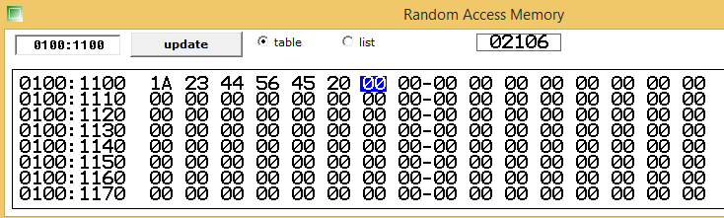

Search elelemt in destination reg

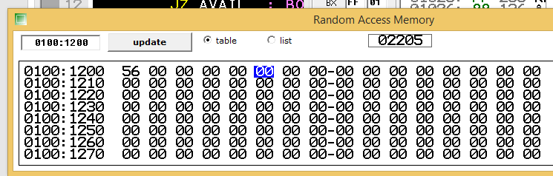

Final search result including element position and address

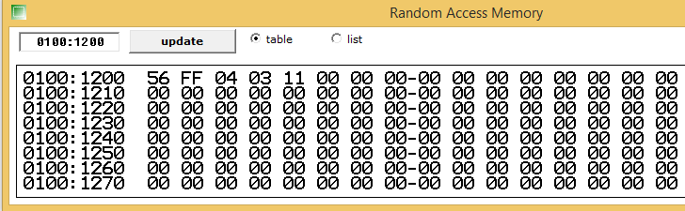

Average of 5 numbers

; average of 5 numbers

DATA SEGMENT

SUM DB 01 DUP(?) ; BYTE MEMORY RESERVED

AVG DB 01 DUP(?) ; BYTE MEMORY RESERVED

DATA ENDS

CODE SEGMENT

ASSUME CS: CODE DS:DATA

START:

MOV AX,DATA ; INI DATA SEGMENT REG

MOV DS,AX

MOV AX,00 ; SET AX AS 00

MOV AL,04 ; MOV 4 IN AL REG

ADD AL,02 ; ADD 02 WITH VAL OF AL REG

ADD AL,08 ; ADD 08 WITH VAL OF AL REG

ADD AL,03 ; ADD 03 WITH VAL OF AL REG

ADD AL,03 ; ADD 03 WITH VAL OF AL REG

MOV SUM,AL ; AL IS MOVED TO SUM

MOV BL,05 ; MOV 05 TO BL

DIV BL ; DIVISION PERFORED

MOV AVG,AL ; STORE THE AVG CAL IN AVG

CODE ENDS ; END CODE SEGMENT

END START ; END PROG

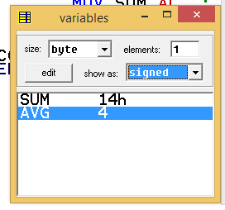

BCD of 2 numbers:

.MODEL SMALL

.CODE

MOV AL,25H

MOV BL,47H

;MOV AL,99H

;MOV BL,99H

ADD AL,BL

DAA

MOV AH,4CH

INT 21H

END

Output:

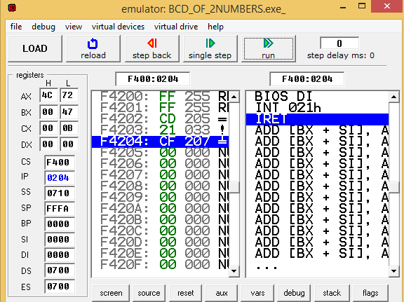

FACORIAL OF A NUMBER

.DATA

ANS DB ?

.CODE

MAIN PROC

MOV AX,@DATA

MOV DS,AX

MOV AL,5

MOV CL,4

MOV BL,AL

SUB BL,1

L1:

MUL BL

SUB BL,1

LOOP L1

MOV ANS,AL

END MAIN

RET

OUTPUT

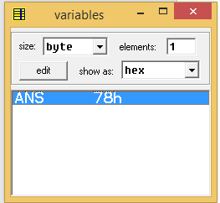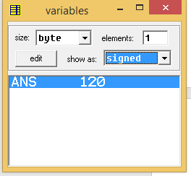

HCF AND LCM

DATA SEGMENT

NUM1 DW 1500

NUM2 DW 2500

HCF DW ?

LCM DW ?

ENDS

CODE SEGMENT

ASSUME DS:DATA CS:CODE

START:

MOV AX,DATA

MOV DS,AX

MOV AX,NUM1

MOV BX,NUM2

WHILE:MOV DX,0

MOV CX,BX

DIV BX

MOV BX,DX

MOV AX,CX

CMP BX,0

JNE WHILE

MOV HCF,AX

MOV CX,AX

MOV AX,NUM1

MOV BX,NUM2

MUL BX

DIV CX

MOV LCM,AX

MOV AH,4CH

INT 21H

ENDS

END START

OUTPUT:

